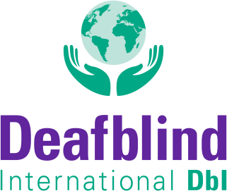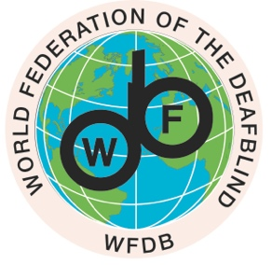

MEMORANDUM OF UNDERSTANDING

between DEAFBLIND INTERNATIONAL (DbI)
and THE WORLD FEDERATION OF THE DEAFBLIND (WFDB)

DbI is an international not-for-profit membership organisation focused on the needs of persons with deafblindness, their families, researchers and the professionals who provide deafblind-specific services. DbI is all about connecting to maximize positive impact for and with all those concerned and involved, connecting to make a real difference in the lives of people with deafblindness around the world.
DbI has a constitution, members from around the globe, 17 thematically or geographically focused Networks and is managed by a volunteer Board and a volunteer Management Committee, assisted by additional standing Committees like the Communication Committee.
DbI’s core is well captured in the claim "Connect to Act".

WFDB has attained acknowledgment and recognition as the unified and legitimate global representative and the voice of persons with deafblindness. WFDB aspires to improve the quality of life of persons with deafblindness worldwide and to achieve equal rights and equal opportunities in all areas of society. Also, WFDB aims to develop and remain a worldwide forum for the exchange of knowledge and experiences in the area of deafblindness, and to increase international solidarity among organisations of people with deafblindness. WFDB is a point of connection on any global advocacy action related to Deafblind persons with national and international members and partners, as well as with external institutions such as IDA, IDDC, UN, etc. The main principle of WFDB follows the well-known UN’s motto, and that is: “Nothing about US (Deafblind) without US (Deafblind).”

DbI and WFDB agree that it is valuable and of utter importance to unite around the common goals of collaboration and alignment of strategic actions related to the awareness and broader understanding of the rights and needs of persons with deafblindness and the establishment, development, and promotion of disability-specific services to all persons with deafblindness.

The Memorandum will serve as an outline to support each other’s strategic goals and initiatives.

1. DbI and WFDB will actively exchange knowledge and information regarding each other’s organisations, and strategic plans and promote an understanding of their work. This also includes communal events coordination to provide mutual encouragement and support.

2. DbI and WFDB will strengthen and expand the reach of their publications, announcements, and official statements in the field of deafblindness. Through this partnership, both organisations will be able to exchange, promote, and disseminate each other's work, ensuring that their combined efforts have an even greater impact.

3. DbI and WFDB agree to engage in joint efforts of research promotion, campaigning releases, policy development, and conferences, forming joint committees, working groups and project teams and/or inviting representatives to join committees, working groups and project teams of WFDB or DbI if appropriate and funding is available.

4. DbI and WFDB will offer each other a standing agenda item at each other’s respective Board and Executive Council/Management Committee meetings. The Presidents of each organisation will meet at least annually. A representative of each organisation may be invited to attend each other’s respective Board and Executive Council/Management Committee meetings if appropriate and funding is available.

This Memorandum of Understanding will remain in effect from the date of signature for a period of 4 years or until either party decides to terminate it by providing the other with ninety days prior notice in writing.

In witness whereof the parties have hereto executed these presents on the date below.

Date: February 28, 2024

For Deafblind International (DbI) | For The World Federation for the Deafblind (WFDB)
Mirko Baur  President | Sanja Tarczay  President
