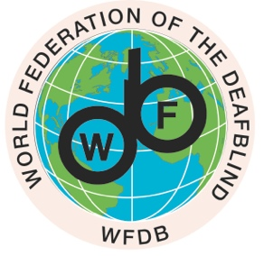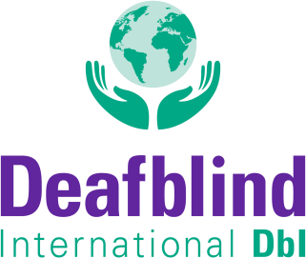

INTERNATIONAL DAY OF EDUCATION:
WFDB and DbI Call for the Immediate Respect of the Right to Education of ALL Children with Deafblindness

Every child has the right to education!
Both the UN Convention on the Rights of the Child and the Convention of Rights of Persons with Disabilities proclaim the right to education and full and equitable inclusion of children with disabilities in society.
However, children with deafblindness are still being left behind.
The 1st Global Report on Deafblindness by the World Federation of the Deafblind WFDB in 2018 made it clear: Children with deafblindness are up to 23 times less likely to be in school than children without disabilities, and less likely to be in school than children with other disabilities.
The 2nd Global Report by WFDB in 2023 explored the situation of children living with deafblindness further in 36 countries across the globe. The results are devastating: only 14% are enrolled in education.
The newest comparative data by Deafblind International DbI, which focuses on 27 countries in Africa, Asia, and Latin America, shows that there is still an enormous need for quality education from pre-school to vocational training, for research, and for assistive technology in far too many places.
The current state of affairs is clearly unacceptable. Therefore, WFDB and DbI call, on this International Day of Education 2024, for the immediate respect of the right to education of all children with deafblindness.
The vision and mission of DbI's current global education campaign "LET ME IN", which is being implemented in close collaboration with the WFDB, is to bring about effective change in education for these children. Many other important international organisations such as the International Council for Education of People with Visual Impairment ICEVI are also on board.
The campaign, which has the potential to reach 5.5 million children, guarantees regionally relevant goals and coordinated projects in a culturally and systemically appropriate form on the basis of growing regional competence networks. In Africa, the campaign is perfectly aligned with the African Union’s theme for 2024:
« Educate an African fit for the 21st Century: Building resilient education systems for increased access to inclusive, lifelong, quality, and relevant learning in Africa ».
Let’s work together across all borders, and despite differences, conflicts, wars, natural and human-made disasters.
- To make pre-school and school accessible for all children with deafblindness
- ensuring inclusive environments,
- quality support,
- and provision of deafblind interpreters, communication guides, intervenors or assistants, depending on the individual needs.

Together we can realize inclusive, lifelong, quality and relevant education for persons with deafblindness worldwide. Any support is welcome on this journey. Please reach out to either one or both of us.

Zagreb and Zurich, January 24, 2024

Sanja Tarczay, WFDB President Mirko Baur, DbI President
president@wfdb.eu mbaur@deafblindinternational.org

