# 

# November 2023

# Public letter by The World Federation of the Deafblind (WFDB)

# Violations of human rights in Haiti against persons with deafblindness

Violence in Haiti has increased dramatically since the start of 2023. This includes violations of human rights from criminal groups against civilians such as killings, kidnappings, torture, rape. Disadvantaged groups such as persons with disabilities are being particularly targeted and hit the hardest.

Amnesty International, Human Rights Watch and UN Human Rights Office, amongst others, have published multiple reports on the matter and public statements calling for a cease of these violations of human rights.

It is with horror and outrage that The World Federation of the Deafblind (WFDB) received terrible news on Friday 10th of November from our member in Haiti, Union of Haitian Deaf Blind (UHDB). 25 members of their organization have been kidnapped and women with deafblindness have been sexually assaulted, tortured and beaten by these armed gangs. Many others have been forced to flee their homes and find shelter elsewhere, such as in churches.

Persons with deafblindness, amongst other people with disabilities, are experiencing famine and living in inhuman conditions.

**WFDB strongly condemns all violence against civilians, persons with disabilities, and all vulnerable people.**

**The international community must show its outrage, solidarity and cooperation to stop this situation. We must also support the victims and ensure their safety and their wellbeing, with a particular attention to disadvantaged groups, like persons with deafblindness.**

**Endorsed and supported by:**

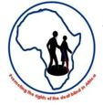

African Federation of the Deafblind (AFDB)

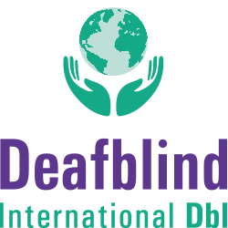

Deafblind International (DbI)



European Deafblind Union (EDbU)



European Disability Forum (EDF)

  
  
 International Disability Alliance (IDA)



International Disability and Development Consortium (IDDC)



Sense International