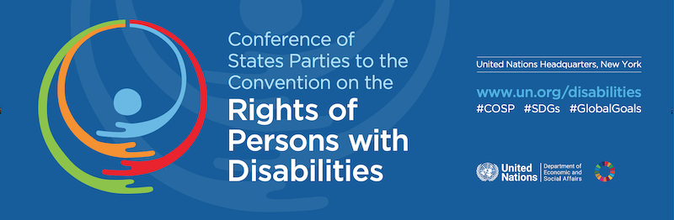

Agenda

CoSP16 Online Side Event
Presenting WFDB’s 2nd Global Report: Good Practices and Recommendations for the Inclusion of Persons with Deafblindness

Wednesday 14th of June 2023

9:45am - 11:00am EST (3:45pm-5:00pm CET)
----------------------------------------------------------------------
Moderator: (TBC)
9:45 – 10:00 Introductory remarks from WFDB President, Sanja Tarczay

10:00 – 10:30 Presenting WFDB’s 2nd Global Report: Good Practices and Recommendations for the Inclusion of Persons with Deafblindness
Presenter (TBC)
10:30 – 10:40 SHAPES Project and the inclusion of older persons with deafblindness
Lucia D’Arino, WFDB Program Advisor

10:40 – 11:00 Questions and remarks from the floor

