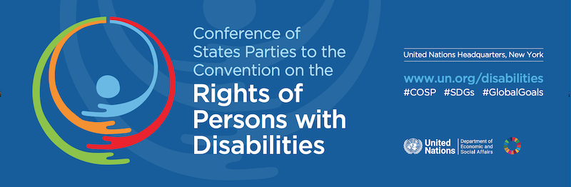

Agenda
CoSP16 Online Side Event
Presenting WFDB’s 2nd Global Report: Good Practices and Recommendations for the Inclusion of Persons with Deafblindness

Wednesday 14th of June 2023

9:45am - 11:00am EST (3:45pm-5:00pm CET)

The event will be held in English. International Sign interpretation and
speech-to-text will be provided.
Click here to register.
---------------------------------------------------------------------
9:45 – 10:05 Introductory remarks

Ms. Sanja Tarczay, WFDB President
Mr. Cato Lie, IDA Board member

10:05 – 10:30 Presenting WFDB’s 2nd Global Report: Good Practices and Recommendations for the Inclusion of Persons with Deafblindness

Mr. Christopher Woodfill, WFDB Executive Council Member
10:30 – 10:45 SHAPES Project and the inclusion of older persons with deafblindness
Ms. Lucia D’Arino, WFDB Program Advisor
10:45 – 11:00 Questions and remarks from the floor

