Easy to Read Summary of the 2nd Global Report on Deafblindness

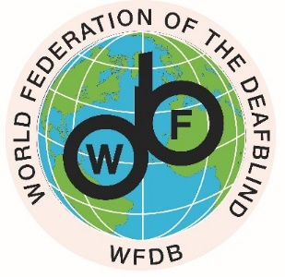
This document is about the second worldwide report on deafblindness. It was published in March 2023.

The World Federation of the Deafblind (WFDB) embarked on this second global report.

It will tell you about what the report recommends to make things better for people who have deafblindness.

If a person is deafblind, it means they have problems hearing well and seeing well. Not all people with deafblindness are completely deaf and completely blind. Some can see and or hear a bit.

When someone experiences deafblindness it affects:

- how they communicate with other people

- access to information they need

- access to the environment and move around

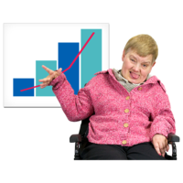

People with deafblindness make up 0.2% to 2% of the population and they are one of the most excluded groups of people in the world.
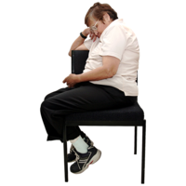
Being excluded means that people are left out of things and are not included in activities or decisions that are important to them.
People with deafblindness need accessibility measures.
This means they need support to make the environment and information more accessible to them.

People with deafblindness need access to reasonable accommodation.
This means that things can be changed for somebody, for example, if they are involved in education or employment to make it easier for them to take part and to be included.

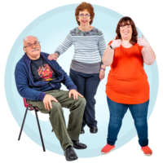
Reasonable accommodations can happen in any area of life to help make a situation better or more accessible.

People with deafblindness also need access to support services that are just for them and support their individual needs.
These supports are things such as interpreter-guides, also called deafblind interpreters and assistive devices and technologies.

These supports help them move past bad attitudes, environmental, and real barriers.

In the research for the global report the findings and results were grouped into the areas below and this will tell us the areas where people who experience deafblindness may need support to do things.

The results are in two sections on the next page.

- Areas that will need action to support more inclusion for people with deafblindness
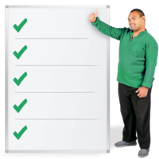
- People need to understand that deafblindness is a disability of its own
- Tackling stigma and discrimination
- Accessibility
- Disability services that are useful also for people with deafblindness
  - Identification, assessment, and referral
  - Rehabilitation and supports and communication
  - Assistive devices and technologies and accessible technologies
  - Interpreter-guides/deafblind interpreters and
  - Other forms of everyday support or help
- People with deafblindness taking part in society

- Areas of Laws and Policies where people with deafblindness should be included in the same way as everyone else
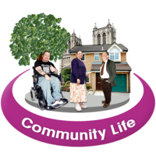
- Inclusive education
- Health
- Work, employment, and any type of training
- Social protection and state benefits and disability payments
- Taking part in public and political life
- Taking part in sport/ leisure and social life
- Making sure violence, abuse, and taking advantage of people doesn’t happen and taking action when it does happen
- Taking action when emergencies happen

The report provides recommendations across the 18 key policy areas above, creating a plan for real change. The first steps to make sure persons with deafblindness are not left behind, are listed below:
The Recommendations

- Understanding and believing that Deafblindness is a real disability with its own challenges, barriers, support and things people need to be included

- Making system for information resources and ongoing training on deafblindness in all languages for professionals in education, rehabilitation, health, social work, and other areas, to understand, identify, educate, and support persons with deafblindness

- Giving Public funding for important services people need like interpreter-guides/deafblind interpreters and teaching assistants

- Funding for further research and collecting information to show that disability services are following the United Nations Convention on the Rights of Persons with Disability (also called UNCRPD) and include the participation of persons with deafblindness and their Disabled Person’s Organisations.

If these recommendations happen, they will help to make sure that people who have Deafblindness to have more social inclusion, participation, independence and choice over their own supports and lives.

